|  |  |  |  |
| --- | --- | --- | --- |
| **paf_kiet_logo** | **COLLEGE OF COMPUTING AND INFORMATION SCIENCES** | | |
| **Mid-Term Assessment fall 2020 Semester** | | |
| **Class Id** | 10509 | **Course Title** | DISCRETE MATHEMATICS |
| **Program** | MCS/BSCS | **Campus / Shift** | CITY CAMPUS / evening |
| **Date** | 24th – oct 2020 | **Total Marks** | 52 points |
| **Duration** | 02 hours | **Faculty Name** | Sanjay Kumar |
| **Student Id** |  | **Student Name** |  |

**Instructions:**

* Fill out your Student ID and Student Name in above header.
* Do not remove or change any part question paper.
* Write down your answers with title “Answer for Question# 00”.
* Handwritten text or image should be on A4 size page with clear visibility of contents.
* In case of CHEATING, COPIED material or any unfair means would result in negative marking or ZERO.
* **Caution:** Duration to perform Mid-Term Assessment is **02 hours only**. Extra 3 hours are given to cater all kinds of odds in submission of Answer-sheet.

**Faculty Signature**

**(10 points)**

**Question # 1:**

1. Use De Morgan’s Law to find the negation of the following statements.
2. Sunny is good in chemistry but not a teacher.
3. Students have passed the board exams and promoted in next class.
4. The classes will be on or it will go online.

1. Express the system using propositions P: ‘You can see movie ’, q : ‘You are free’ , r: ‘You have done your homework’ and connectives (including negations).
2. You can see the movie only if you are free and you have done your homework.
3. You have done your homework but you are free.
4. If you cannot see the movie then you have not done your homework
5. Write contra positive of part iii)
6. Use properties to verify the equivalences.

¬ (p ∨ (¬p ∧ q)) = ¬p ∧ ¬q

**Question # 2: (12 points)**

1. Let N(x) be the statement x has visited Hyderabad and M(x) be the statement x is a traveler. Express each of the quantification into English.

i) ∀x (N(x) ˄M(x)) ii)  ∃x(N(x)🡪M(x))

iii) ¬∀x (M (x ) ) iv) ¬ ∃x(N(x)˄M(x))

1. Express the following statement using quantifiers. Then form the negation of the statement so that no negation to the left of the quantifier.
2. All dogs have fleas.
3. There is an elephant that can swim.
4. Every kangaroo can climb.
5. Nobody can speak French in our village.
6. Determine the truth values of each of these statements if domain of each variables contain all real numbers.

.



**Question # 3: (10 points)**

1. Suppose U={1,2,3,……..10}, Z={3,4,5}

Y={yIy=2z, x $∈$ Z)}, X={$x$ I $x^{2}-11x+28=0$}

Enumerate

$(\left(X∪Y\right)∩\left(Z∪Y\right))$

$X-Z$

3. Y ∪ Z
4. Let

U={1,2,3,4,5} C={1,3}

And A and B are non empty sets. Find A in each of the following

1. $A∪B=U$**, $A∩B=∅$ and B={1,2}**
2. $A∁B$**and $A∪B=\{4,5\}$**

$A∩B=\left\{3\right\},$ $A∪B=\left\{2,3,4\right\},$ $B∪C=\{1,2,3\}$

**Question # 4: (10 points)**

1. In a school, 100 students have access to three software packages,

A, B and C

28 did not use any software

8 used only packages A

26 used only packages B

7 used only packages C

10 used all three packages

13 used both A and B

1. Draw a Venn diagram with all sets enumerated as for as possible. Label the two subsets which cannot be enumerated as x and y, in any
2. If twice as many students used package B as package A, write down a

pair of simultaneous equations in x and y.

1. Solve these equations to find x and y.
2. How many students used package C?
3. Write the expression for the following shaded region

**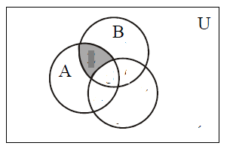**

1. Using set identities prove the below expression

A – (A – B) = A ∩ B

**Question # 5: (10 points)**

1. Prove or disapprove the following statements about ceiling and floor. Show it with a suitable example.

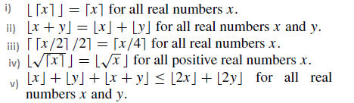

1. Express the following summation in simplest form use appropriate summation rule.

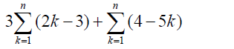

1. Function f and g are defined for x $∈R$ by f (x) = 5x + 4 and g (x) = x – 3 , what will be the value of x if

(f ∘ g) (x) = 6

**BEST OF LUCK**